

**INDIAN INSTITUTE OF INFORMATION TECHNOLOGY, LUCKNOW**

**B.Tech Project Report**

**Project Title :**

**Helpdesk Portal System For IIIT Lucknow**

**Supervisor** **:** Dr. Vishal Krishna Singh

**Group Members :**

1. Chetan Joshi LIT2017010
2. Hidayat Ullah Khan LIT2017029
3. Gaurav Singh LIT2017031

**CANDIDATES’ DECLARATION**

We hereby declare that the work presented in this project report entitled **Helpdesk Portal System**, submitted as a mini project report of 6th Semester B.Tech. (IT) at Indian Institute of Information Technology, Lucknow, is an authenticated record of our original work carried out from January 2019 to May 2019 under the guidance of Dr.Vishal Krishna Singh. Due acknowledgments have been made in the text to all other material used. The project was done in full compliance with the requirements and constraints of the prescribed curriculum.

Place: IIIT Lucknow

Date: 18 Feb, 2020

Chetan Joshi(LIT2017010)

Hidayat Ullah Khan(LIT2017029)

Gaurav Singh(LIT2017031)

**SUPERVISOR CERTIFICATE**

I do hereby recommend that the project report prepared under my supervision by **Chetan Joshi(LIT2017010), Hidayat Ullah Khan(LIT2017029) and Gaurav Singh(LIT2017031)** titled **Helpdesk Portal System**, be accepted in the partial fulfillment of the requirements of the completion of 6th semester of Bachelor of Technology in Information Technology for the Examination.

Place: IIIT Lucknow

Dr. Vishal Krishna Singh

Assistant Professor

IIIT Lucknow

Date: 19 Feb, 2020

**Index**

Introduction 1

Project Definition and Scope 2

Literature Survey 3 - 4

Proposed Approach 5

Flowchart Diagrams 6 - 7

Hardware and Software Requirements 8

Expected Results and Discussion 9

Activity Time Chart 10

References 11

**Introduction**

This project is aimed at developing an **Online Helpdesk Portal System** for the facilities in the IIIT Lucknow campus. This is a web based application that can be accessed throughout the campus. This system can be used to automate the workflow of service requests for the various facilities in the campus. This is one integrated system that covers different kinds of facilities like class-rooms, labs, hostels, mess, canteen, etc. Registered users (students, faculty-head and admin) will be able to log in a request for service for any of the supported facilities. These requests will be sent to the concerned people, who are also valid users of the system, to get them resolved.

**Motivation :**

Helpdesk Portal Systems are mainly used in colleges with large numbers of students. Manual methods of checking students’ information will no longer be there again because it will be done by the computer with the help of the computerized Online Help Desk Portal. Because of the easy to use nature of the Help Desk Portal, any organization can easily buy it to make use of them. The goal of this project is to develop a practical online helpdesk system for facilities in the campus.

**Project Definition And Scope**

**Definition :**

The aim and objective of this project **Online Helpdesk Portal System** is to develop a software that will replace the manual method of complaint filing and management. This project is developed to promote and provide adequate and efficient methods of complaint. This project eliminates the time and energy involved in manual complaint filing and tracking of the complaint. This web based application can be accessed using valid issued college email. The system can be used to automate the workflow of the service requests for the various facilities in the campus. In order to streamline support requests and serve better, we utilize a support ticket system. Every support request is assigned a unique ticket number which can be used to track the progress and responses online. For reference a complete archive and history of all your support requests. A valid college email address is required to submit a ticket.

**Scope :**­

This project is a **Helpdesk Portal System**, wherein the students can register their complaints regarding the infrastructure and all other facilities in the campus. The complaint filed is then forwarded to the concerned authorities (maybe a maintenance cell) which can then review the problem and act accordingly.Each complaint filed can be considered as a Ticket. Priorities are associated with each ticket. The user then gets an auto-generated email as confirmation of the complaint.

**Literature Survey**

Following papers shows case studies and references to use of helpdesk portal system which inspired us for our project:

1. Helpdesk service comprises of electronic request from the user on a specified problem and the system enables the user to get his/her problem resolved by the system. The system can be manual i.e., handled by a service provider or it can automatically perform a search in a knowledge based system to find potential solutions and assign confidence ratings to the solutions[1].
2. OSU Helpdesk, which has core features like secure logon, web and email-based ticket entry, and powerful query and report tools. (Case Study) [2]
3. iHelp, an intelligent online helpdesk system, to automatically find problem-solution patterns from the past customer-representative interactions. When a new customer request arrives, iHelp searches and ranks the past cases based on their semantic relevance to the request, groups the relevant cases into different clusters using a mixture language model and symmetric matrix factorization, and summarizes each case cluster to generate recommended solutions.(Case Study)[3]
4. (Case Study:WebHotLine)[4]The paper describes the basic architecture of the environment that supports the major functions of Web-based fault information retrieval, online multilingual translation capability, different operating modes of video-conferencing for enhanced support and direct intelligent fault diagnosis by customers or customer support engineers. As a result, it helps to save cost in eliminating the expensive overseas telephone charges, reduction in machine down time and number of on-site visits by service engineers as in traditional helpdesk environment.
5. Usefulness of helpdesk[5]: The paper analyzes usefulness of helpdesk system and typical structure of a helpdesk call and strategies to make helpdesk query successful.

**Proposed Approach**

In order to make the handling of maintenance tasks smoother in college premises, we are proposing an online web portal system which will enable everyone on the campus to register maintenance related complaints and thus help in quick resolving of those issues. The portal will allow the user to generate complaint ticket, track past complaints and provide additional information like priority of the task , unit number, location etc. The user can also add photos related to the complaint as attachment file.

The system will provide 2 main features to the user:-

1. Submitting a ticket
2. View past record of generated tickets

While submitting a ticket the user fills a detailed form, which includes all the relevant information to the complaint. The system then generates a unique ticket for each complaint and send the complaint information to maintainer email id, and also send the acknowledgement to the user.

The user can also view existing ticket and can also access the tracking id of previous complaints.

**FLOW CHART DIAGRAM**

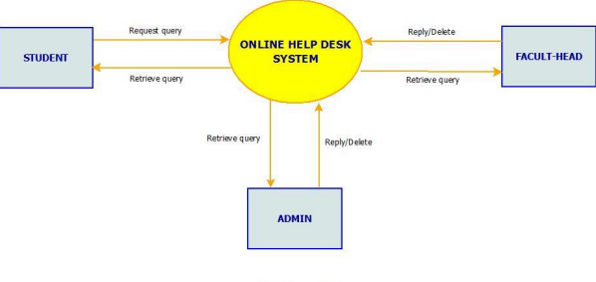

**Data Flow Diagram**

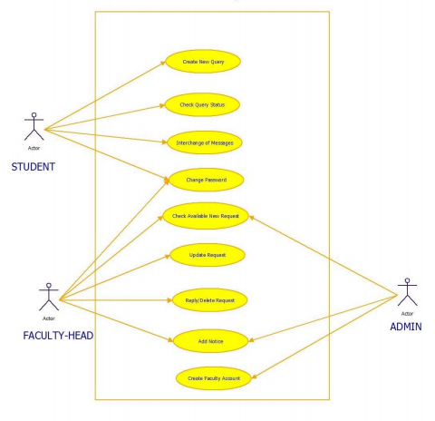

**Use Case Diagram**

**Hardware & Software Requirements**

**Hardware Requirements :**

1. PC
2. University network infrastructure (wired and wireless).
3. Mac, Unix and Windows client computers
4. The environment that will host the university-wide databases
5. Web server computer(s) and related hardware support (redundant drives, UPS, etc.)

**Software Requirements :**

* Django
* Python
* HTML / CSS
* Other python modules and packages

**Expected Results and Discussion**

This project is the small step to reduce the communication distance between the staff and the students. As the growing use of computers and other electronic devices would mean the growing demand on rapid and quick technical support, this Help Desk Support System is carefully designed to fit with the rapid technical support. It not only helps reducing the time of recording and tracking inquires and problems traditionally, but also improves quality and accuracy of data produced by the system which can lead to more facilitation of decision making process in time. Help Desk Portal System is designed to accommodate future upgrading and development without the need for building a new system to fit with the growing needs and demands of the system. Having this system hosted online means the ability of both technicians and administrator to track and respond to demands of students at any time beyond the boundaries and walls of college which add one more advantage to replacing the paper-based style.

**Activity Time Chart**

|  |  |
| --- | --- |
| **PROJECT ACTIVITY** | **DURATION** |
| Learn Various Languages and its libraries/frameworks for Web Interface. | Week 1- Week 2 |
| Analyzing requirements and setting up the environment | Week 3 |
| Learning and testing some basic programs in Web Development . | Week 4 |
| Implementing the Helpdesk Portal and its ticketing interface. | Week 5 |
| Adding basic features to the project, eg : Login, SignUp, Ticket Generation,etc . | Week 6 |
| Adding advanced features and testing the project in different environment. | Week 7 |

**References**

[1] <https://patents.google.com/patent/US20030172133A1/en>

[2] <https://dl.acm.org/doi/abs/10.1145/1027802.1027851>

[3]<https://ieeexplore.ieee.org/abstract/document/5475278>.

[4]<https://www.tandfonline.com/doi/abs/10.1080/00207720210133642>

[5]<https://ieeexplore.ieee.org/abstract/document/4464071>

**Other References :**

<https://djangobook.com/mastering-django-2-book/>

<https://tutorial.djangogirls.org/en/>

**Remarks :**

**Signature Of Mentor :**

**Signature Of Panel :**